 | International Society for Labour and Social Security Law  Société internationale de droit du travail et de la sécurité sociale  Sociedad Internacional de Derecho del Trabajo y de la Seguridad Social | 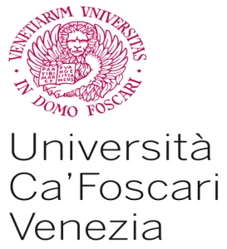

MODULE INSCRIPTION TO THE SEMINAR :
“Fundamental Social Rights in the Age of Globalization”,
Venice, 1-10 July 2014.

PLEASE, FILL THIS MODULE AND SEND IT, SIGNED, WITH YOUR CV AT dirittodelalvoro@unive.it

Name: ………………………………………………………………………………....

Surname: ……………………………………………………………………………….….

Born in (town and Country): ……………….………………………………..

Date: …………………………………………

Permanent Address: .……………………………………………………………………………..…..
…………………………………………………………………………………..

Fiscal Code (if owned) ………………………………………...……….…….

Nationality
…………………………………………………………………….…………….

V.A.T. ( if owned) n°……………………………………………………………

Information required by Italian law Dlgs 196/2003 –
Code on personal data protection

Your personal data provided in the agreement and during your activity are necessary to manage the whole project. Your data will be treated by the organization in different formats (on paper or digital format) and will be transferred electronically for fiscal and administrative purposes.
Exclusively for the above mentioned purposes, your data could be communicated to other organizations which cooperate with Ca’ Foscari Formazione e Ricerca for the development of the programme. Your data will not be further widely divulged for any other reason.
In order to access, modify, update or to deny the use or deletion of your data (ex. Art. 7 of the Dlgs 196/03), you can ask to the organization in charge of data handling: Ca’ Foscari Formazione e Ricerca, Dorsoduro 3858, Venezia, tel 00390412346942, Stefania Torre.

Do you agree with the above conditions?
YES □ NO □

By signing the present form, do you also agree to receive future communications and promotions of similar initiatives, also via email to the address provided?
YES □ NO □

Date ________________________

Signature ____________________________________

Fondazione Università Ca’ Foscari Venezia
Sede legale: Dorsoduro, 3246 - 30123 Venezia
Sede operativa: – Ca’ della Zorza – Dorsoduro, 3858 - 30123 Venezia
 041 234 6940 Fax 041 234 6941 E-Mail fondazione.cafoscari@unive.it

